**Programming language PYTHON**

**Exercise No 1. Simple variable Assignment**

**Step 1**. Declare a variable name and assign your name to it.

name=”Farah”

**Step 2**. Declare a variable age and assign your age to it.

age=19

**Step 3**. Print both variables in readable format.

print(f”{name} age is {age}”)

**Result.**

Farah age is 19

**INPUT:**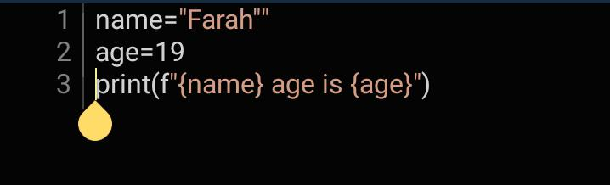

**OUTPUT:**

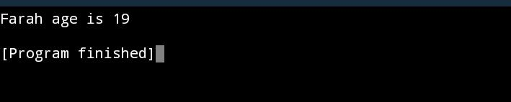

**Exercise No 2.** **Multiple variable Assignment**

**Step 1.** Declare three variable num1,num2 and result.

num1=

num2=

result=

**Step 2.** Assign integer value to num1 and num2.

num1=45

num2=62

**Step 3.** Add num1 and num2 and store result in result variable.

num1=45

num2=62

result=num1+num2

**Step 4.** Print the values of all three variables.

print(f”Number1={num1}”)

print(f”Number2={num2}”)

print(f”Number1+Number2={result}”)

**Result.**

Number1=45

Number2=62

Number1+Number2=107

**INPUT:**

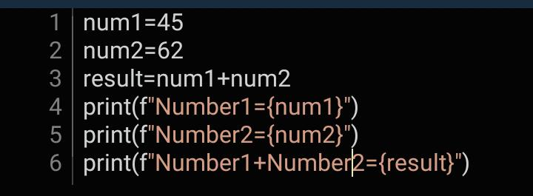

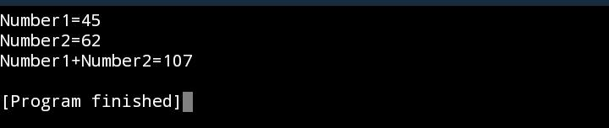**OUTPUT:**

**Exercise No 3. Variable Types**

**Step 1.** Declare a variable price and assign float value to it.

Price=345.7

**Step 2.** Declare a variable quantity and assign the integer value to it.

Quantity=3

**Step 3.** Calculate the total cost (Price*Quantity) and store it in variable Total_cost.

Total_cost=Price*Quantity

**Step 4.** Print the values of three variables.

print(f”Price={Price}”)

print(f”Quantity={Quantity}”)

print(f”Total Cost={Total_cost}”)

**Result.**

Price=345.7

Quantity=3

Total cost=1037.1

**INPUT:**

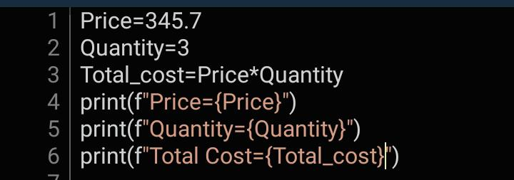

**OUTPUT:**

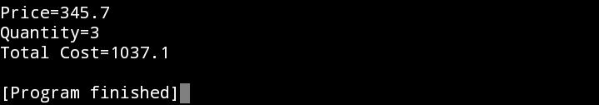

**Exercise No 4. String Concatenation**

**Step 1.** Declare two string variables first_name and last_name and assign your first and last name to it.

first_name=”Farah”

last_name=”Maqbool”

**Step 2.** Concatenate the two strings and store the result in a variable full_name.

full_name=first_name + “ “ + last_name

**Step 3.**  Print the full_name variable.

print(f”{full_name}”)

**Result:**

Farah Maqbool

**INPUT:**

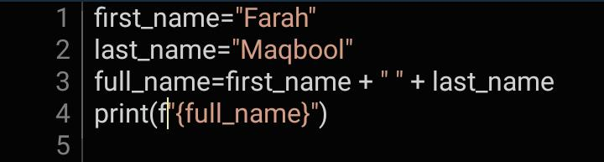

**OUTPUT:**

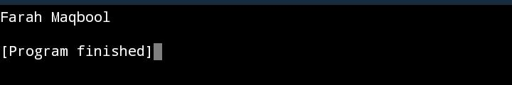

**Exercise No 5.Boolean variable.**

**Step 1.** Declare a Boolean variable is_adult and assign true if you are above 18 otherwise false.

is_adult=18

input=input(“Enter your age: “)

**Step 2. Print the value of the is_adult.**

if int(input)<=is_adult:

print(“True”)

else:

print(“False”)

**Result:**

Enter your age:12

True

**INPUT:**

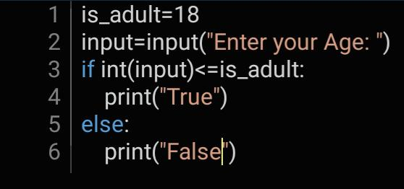

**OUTPUT:**

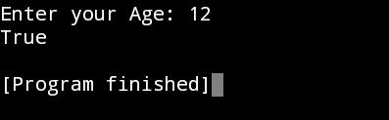

**Exercise No 6. Interactive User input.**

**Step 1.** Use the input() function to get the user name.

Input=input(“Enter User Name”)

**Step 2.** Store the input in a variable called user_input.

user_input=input

**Step 3.** Print the personalized greetings using the user_input.

print(f“{user_input}Thanks For Enrolling”)

**Result.**

Enter User Name=farahmaqbool

Farahmaqbool Thanks For Enrolling

**INPUT.**

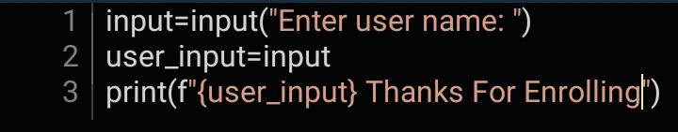

**OUTPUT.**

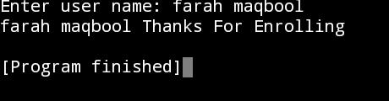

**Exercise No 7. Temperature Conversion**

**Step 1. Declare a variable Celsius_Temperature and assign Celsius temperature to it**

Celsius_Temperature=45

**Step 2. Convert the Temperature.**

f=(Celsius_Temperature* 9/5)+32

**Step 3. Print original Celsius temperature and convert in Fahrenheit**

print(f”In Celsius Temperature={Celsius_Temperature} and in Fahrenheit temperature={f}”)

**Result.**

In Celsius Temperature=45 and in Fahrenheit Temperature=113.0

**Input.**

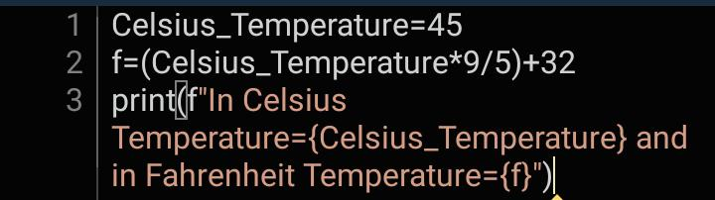

**Output.**

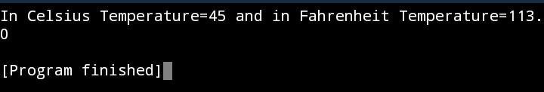

**Exercise No 8. Swapping Variables.**

**Step 1. Declare two variables a and b and assign values to them**

a=4

b=9

**Step 2. Swap the values of a and b without using the temporary variable.**

a=4

b=9

a,b=b,a

**Step 3.** **Print the values of a and b after swapping.**

print(f”A is {a}”)

print(f”B is { b}”)

**Result.**

A is 9

B is 4

**Input.**

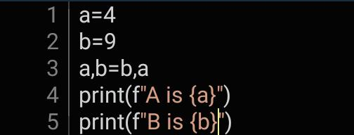

**Output.**

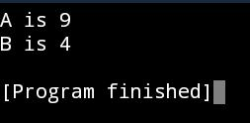

**Exercise No 9.**

**Calculator**

1.Write a Python program that acts as a simple calculator.

2.It should take two numbers and an operator (+, -, *, /) as input from the user.

3.Perform the corresponding arithmetic operation and display the result.

4.Implement error handling to handle cases such as division by zero or invalid operators.

**Input.**

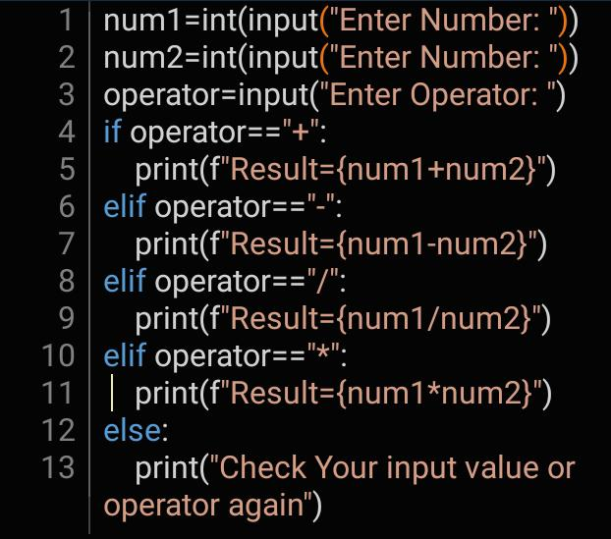

**Output.**

